HOWTO -- Documentation

The documentation is simple and straight forward. Just start with the Introduction and follow the install steps.
I. | Introduction
II. | Prerequisites
III. | Configuring a PC to serve as a host for your images
IV. | Downloading and Burning the PING ISO
V. | Installing your own PXE Server to allow network hosts to boot PING
VI. | Using PING
VII. | Storing an image on a Bootable ISO
VIII. | Annex

Introduction
The following installation steps will let you to backup and restore whole systems through your network or removable media (e.g. CDs, DVDs, and USB mass storage devices).

At the end of the installation, you should be able to boot any computer on a CD/DVD or your network and press the F12 key during the boot process to launch the PING software (PXE). Using this tool, you should be able either to backup, either to restore systems and partitions. Think of it as a Ghost-like process.

Prerequisites
Using PING on a Directly Attached Hard Drive:
- Hard drive space. To store a full 40 GB hard disk, you may need up to 40 GB.

Using PING Over a Network:
- A LAN (Local Area Network). At least two connected computers. One of these computers is to be copied or restored, and the other is supposed to store the images you'll do with PING.
- A Share. The computer used to store the images must be able to share files (any Microsoft Windows computer can). If you are a Linux user, install Samba.
- Space. To store a full 40 GB hard disk, you may need up to 40 GB.

Configuring a PC to serve as a host for your images
SKIP this step if all you want is a locally-stored backup of your system.

Directory names are given here as samples. Adapt the following according to your specific needs and configuration.
- Download PartImage.zip and save it on C:\
- Open C:\ and uncompress the archive (choose: extract here)
- You should have a C:\PartImage directory, containing several subfolders (eg.: a Create_New_Image subfolder)
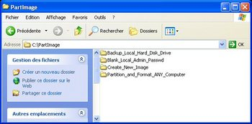

- Right-click on the C:\PartImage folder and share it. Set the permissions as suits you. Just keep in mind that you'll have to be able to write on this shared folder from any host on your network. Create a user if necessary.

Downloading and Burning the PING ISO
SKIP this step if you only want to setup a PXE server.
- Download PING.2.01.iso

- Burn it using your favorite burning software
  - With Nero:
    - Open Nero Burning Rom
    - Select Recorder / Burn Image
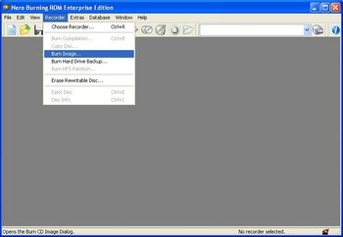

    - Browse to PING.2.01.iso

  - If you have no tool to burn an ISO:
    - Go to Alex Feinman's website and download what IsoRecorder version suits your configuration. It's freeware. Install it.
    - Then, open the folder containing the PING.2.01.iso file, right-click on the ISO, and choose "Copy Image to CD"

Installing your PXE Server to allow network hosts to boot PING (Optional step)
SKIP this step if you only want a backup of your system stored locally or on removable media.

Directory names are given here as samples. Adapt the following according to your specific needs and configuration.
- If you've got a working RIS Server (like MS Windows Server 2000 or 2003) :

  - You probably have a \\server_name\RemInst\Setup\English\Images\ directory, used to share images for the RIS server.

  - Create the following folders:
    - \\server_name\RemInst\Setup\English\Images\PING\
    - \\server_name\RemInst\Setup\English\Images\PING\i386\
    - \\server_name\RemInst\Setup\English\Images\PING\i386\templates\
    - \\server_name\RemInst\Setup\English\Images\PING\i386\templates\pxelinux.cfg\ (yes, this is a folder, not a file)

  - In the \\server_name\RemInst\...\templates\ directory, download the following files:
    - kernel
    - initrd.gz
    - pxelinux.0

  - In the \\server_name\RemInst\...\templates\ directory, create a text file that you'll name ping.sif, containing:
[OSChooser]
Description = "PING 2.01 (Partimage Is Not Ghost)"
Help = ""
LaunchFile = "Setup\English\Images\PING\i386\templates\pxelinux.0"
ImageType = Flat
Version="2.01"

  - In the \\server_name\RemInst\...\templates\pxelinux.cfg\ directory, create a text file that you'll name default (not default.txt), containing:
DEFAULT rescue
PROMPT 0
LABEL rescue
KERNEL kernel
APPEND vga=normal devfs=nomount pxe ramdisk_size=33000 load_ramdisk=1 init=/linuxrc prompt_ramdisk=0 initrd=initrd.gz root=/dev/ram0 rw noapic lba acpi=off

- If you have no working RIS Server and want to build your own easily :

  - Install TFTPD32 from Ph. Jumin's web site

  - On your future PXE / RIS Server, create the following directories:
    - D:\PXE\
    - D:\PXE\i386\
    - D:\PXE\i386\templates\
    - D:\PXE\i386\templates\pxelinux.cfg\

  - In the D:\PXE\i386\templates\ directory, download the following files:
    - kernel
    - initrd.gz
    - pxelinux.0

  - In the D:\PXE\i386\templates\pxelinux.cfg\ directory, create a text file that you'll name default (not default.txt), containing:
DEFAULT rescue
PROMPT 0
LABEL rescue
KERNEL kernel
APPEND vga=normal devfs=nomount pxe ramdisk_size=33000 load_ramdisk=1 init=/linuxrc prompt_ramdisk=0 initrd=initrd.gz root=/dev/ram0 rw noapic lba acpi=off

  - Launch TFTPD and configure it the following way:

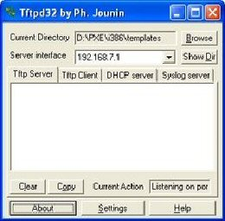 | If you've got several network cards in your computer, you'll have to choose in the server interface area the one that communicates with your other LAN hosts.
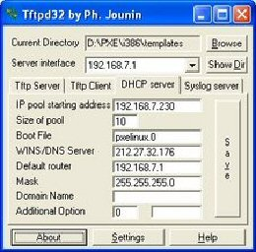 | Configure your DHCP Server here. Booting with PXE is not possible unless you define it. A common network configuration is to have addresses like 192.168.0.x with 192.168.0.1 as the router (often a workstation connected both to the internet, both to the LAN, and sharing the internet connection on the LAN).
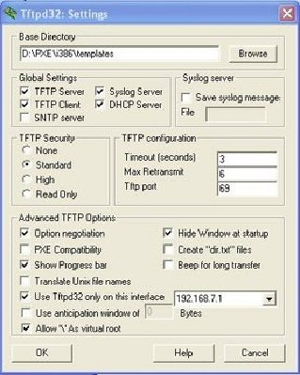 | Nothing special here.

  - That's all ! Test your PXE Server: go to a LAN workstation, reboot it, and press F12 to boot on the network. Note: if you don't see the F12 prompt, you might have to modify the BIOS setup and enable PXE.
In the following section, we'll be booting from a CD, made by burning the PING ISO. But this should give exactly the same result.
Please note that some screenshots might not be up to date, for PING is frequently improved.

Using PING
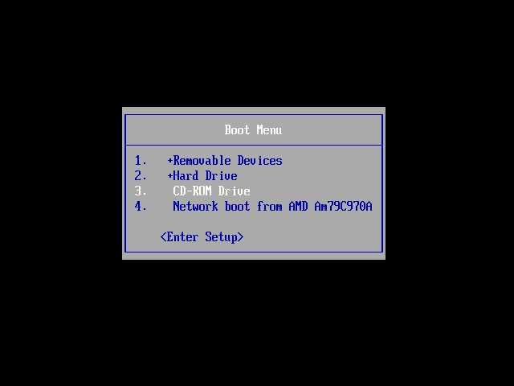 | Choose to boot on the CD you've burnt with the PING ISO.  If you don't see the option in your boot sequence, you'll probably have to modify your BIOS settings.  Note that a PXE Server is needed to boot from the network.
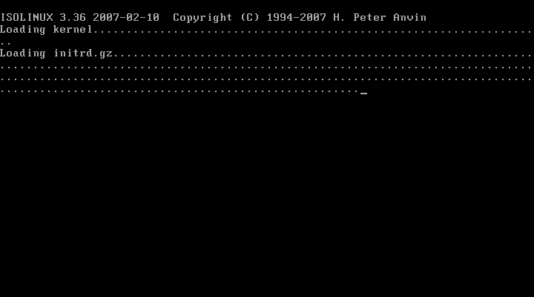 | The Linux distribution is starting.
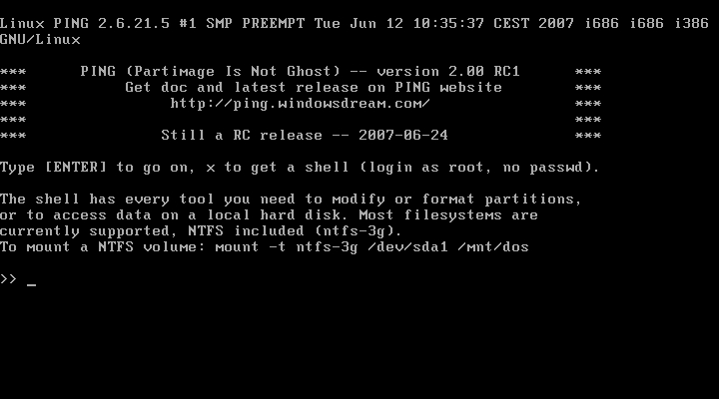 | Press ENTER to proceed.  If you don't want to use our menu-driven wizard, press x and ENTER to get a shell. The root user account has no password.
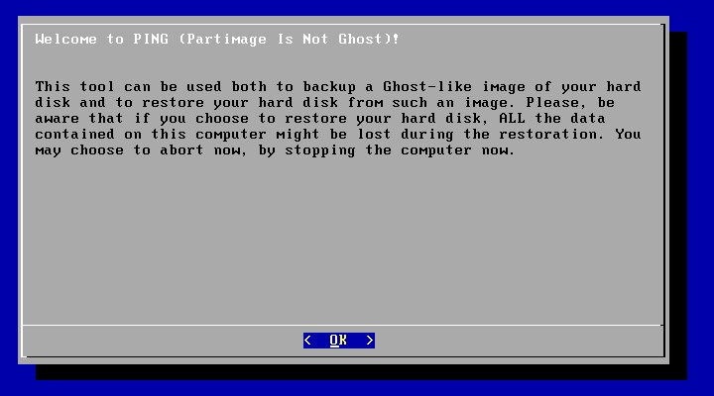 | Read the warnings carefully and press ENTER to proceed.
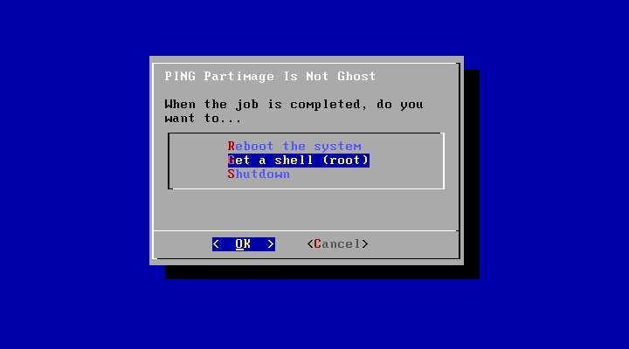 | Choose what should happen at the end of the backup or restoration process. You might want to get a shell to access the log. The command line instruction is “vi /tmp/x.log”.
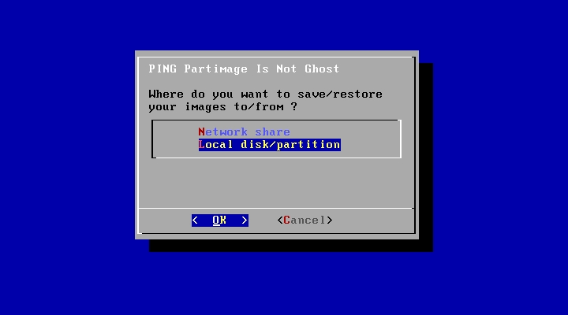 | You can backup to and restore from a local partition or a network drive.  These illustrations will start with a local backup.
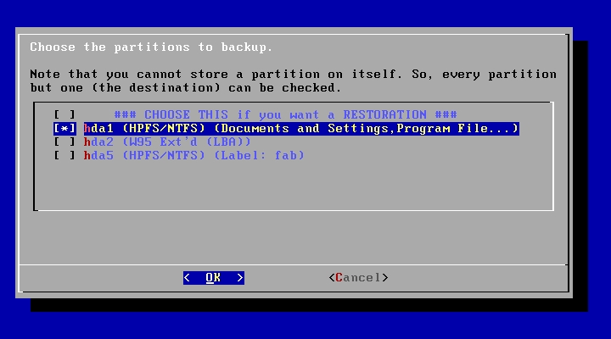 | All available partitions should be enumerated here, with either a NTFS label or the first few directories.  If you want to restore an image to the workstation, select the first option.
Otherwise, select all partitions you want to backup. Be aware that you should leave at least one partition unselected, as PING won’t store a partition onto itself.
An Exception: if you’ve got only one partition, you’ll be able to select it, and the script will suggest splitting the partition into two partitions. Although this works, you may want to repartition the drive before running PING.
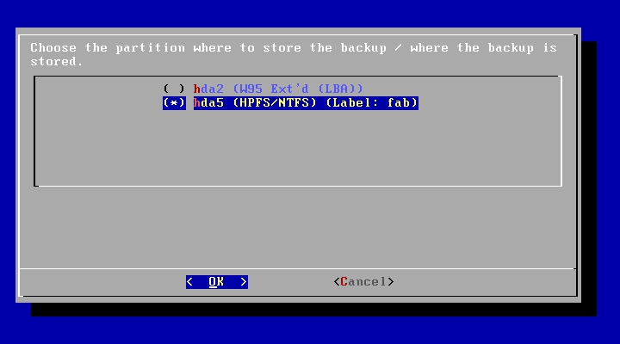 | Now, choose where to store the image.  In our example, we had the C: part on /dev/hda1 and a D: part on /dev/hda5 (which Windows always stores in an extended /dev/hda2 partition). We’ll store an image of C: on D:.
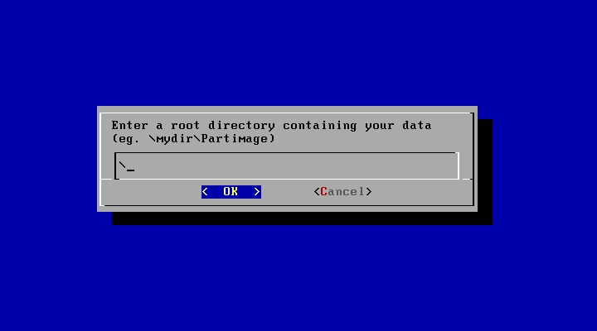 | If you’ve prepared a \Partimage directory on your destination partition, enter it here.  In our case, we had not, and so we entered the root directory (and our first image will be stored on D:\).  It’s a good idea to have everything stored in a dedicated directory.
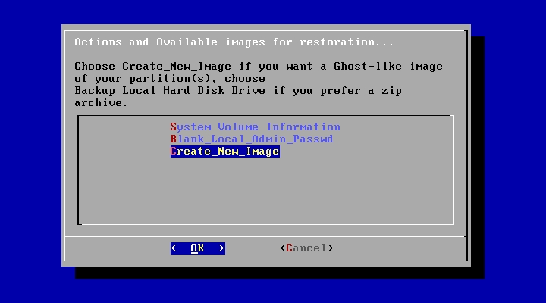 | Here, you'll find the list of available images. They are stored in the directory we’ve just chosen. Choosing one image will restore the computer with it, thus erasing all your hard disk.  Apart the images themselves, you’ll always find 2 special choices,
obviously necessary to let you ask for an image (or blank Windows administrator password, if needed.)
In our example, we had chosen the D:\ directory, and D:\ was empty. That’s why you can see a “System Volume Information” directory, present on any NTFS partition. (We should have created a D:\Partimage directory and chosen it for the example to be clearer – sorry.)
Now, let’s explain what should have happened if we had chosen to store the image onto a Network Share rather than a Local Partition…
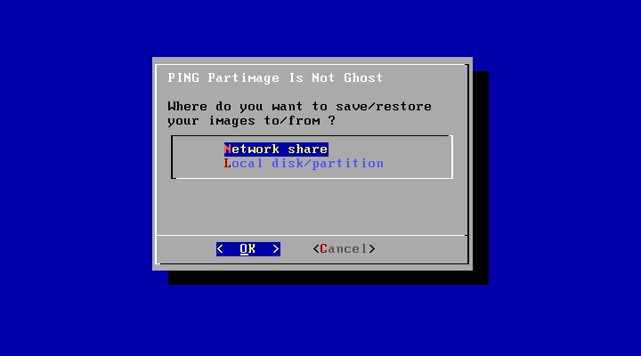 | Remember where we were…  When choosing this option, the script will try to get an IP through DHCP. If this fails, you’ll have the possibility to give manual parameters, as in next screenshots.
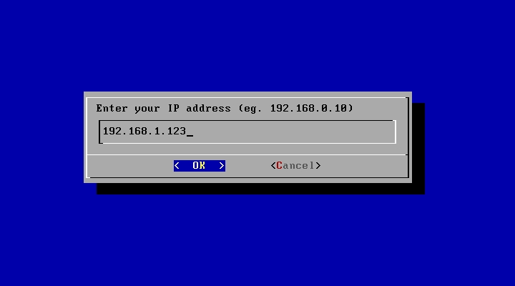 | Give your IP address.
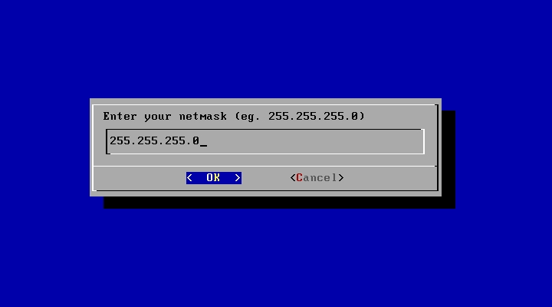 | …and your netmask…
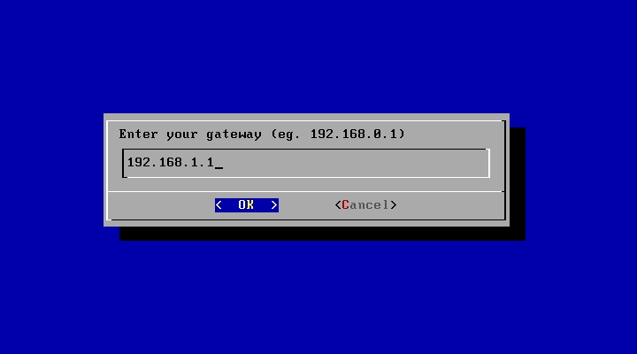 | …and finally your gateway.
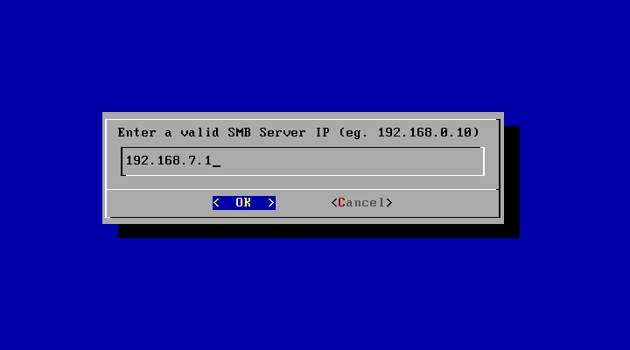 | We need to know where to save the image.  Give the IP of the computer you've shared the PartImage folder on (as explained in the prerequisites).
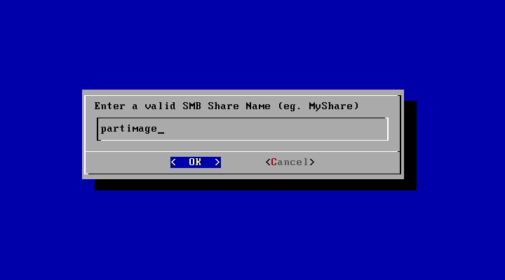 | Now, the name of the share.  Example: \\mydomain\temp => the share is called temp.
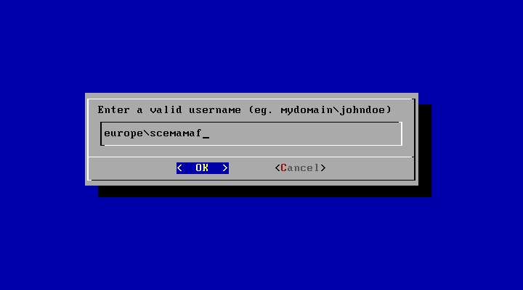 | Now, the user name on the network.  It might also be a local account (eg.: administrator).  (You'll be asked for the password afterwards, and it won’t be displayed when typing it.)
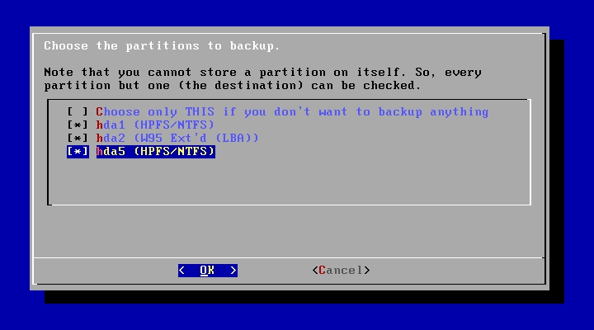 | All connected hard disk drives, USB mass storage devices included, will be scanned and all available partitions should be enumerated here, with either a NTFS label, either first found directories.  If you want to restore an image to the workstation, check the first option.
Elsewhere, choose all the partitions you want to backup. You can choose all of them.
Now, the directory path, from the share to the PartImage directory.
Example: if you created C:\PartImage on server Billy, and shared it, then your resource should be \\billy\partimage. So, IP is Billy's IP, share is partimage, and directory is nothing.
Example: if you created C:\temp\PartImage on server Billy, but shared the temp directory, then your resource should be \\billy\temp\partimage. So, IP is Billy's IP, share is temp, and the directory is \partimage.
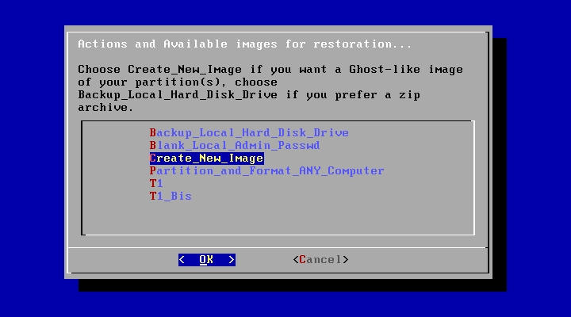 | Here, you'll find the list of available images. In the example, “T1” and “T1_Bis” are two available images. They are stored in the directory we’ve just chosen. Choosing one image will restore the computer with it, thus erasing part of or all your hard disk.
- The Create_New_Image option is obviously not an image, but a choice permitting to create a new one out of the system you’ve booted on.
- Do not confuse it with the Backup_Local_Hard_Disk_Drive option, which will only make a big zip of your disk (which is rarely useful).
- If you need to blank the password of your local administrator, choose Blank_Local_Admin_Passwd.
- Finally, the Partition_And_Format_ANY_Computer is used to prepare a disk for the installation of Windows, by making a 20-GB C:\ partition, and a D:\ with the remaining. The C:\ is ntfs-formatted, but not the D:\. This tool is generally useful to admins needing to install Windows XP through an unattended RIS setup. The answers .SIF file has no option to permit a 20-GB C:\ part to be created on the fly…
- Note that partitionning, be in Partition_And_Format_ANY_Computer or in the restoration of an image you’ve created can be customized through a hda.part / sda.part file. Go to the Annex for details.
We’re back again to common trunk of the documentation, whether you chose to store the image onto a Network Share or onto a Local Partition.
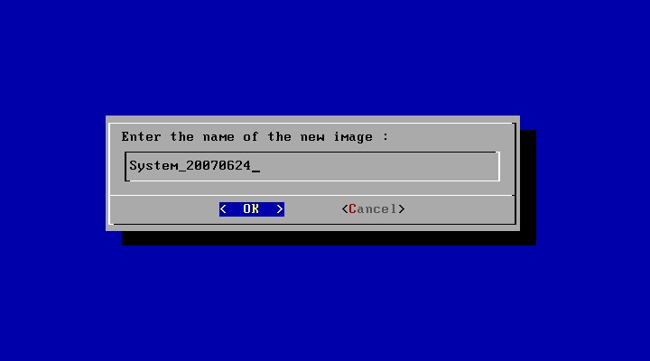 | Finally, tell the wizard what to name your new image.  In this example, PING will create a new \PartImage\System_20070624 directory on the destination drive, and store the backup in it.
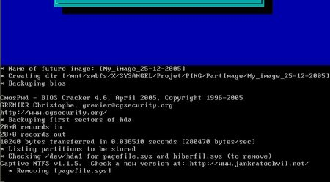 | That's all.  In this screenshot, BIOS settings are being saved...
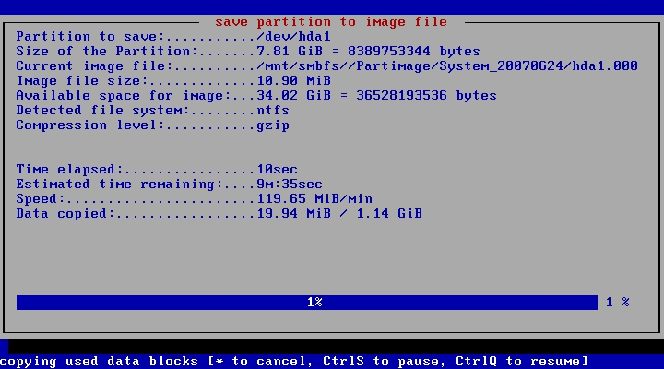 | Then, the partitions...
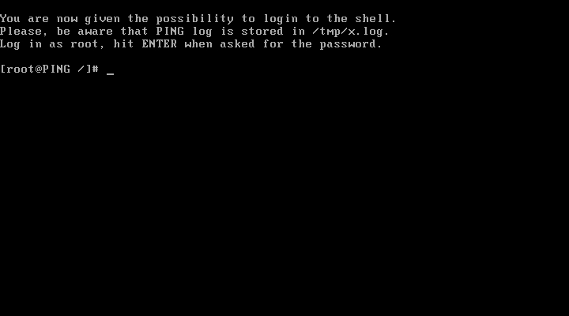 | When the process is over, we get the shell we asked for.
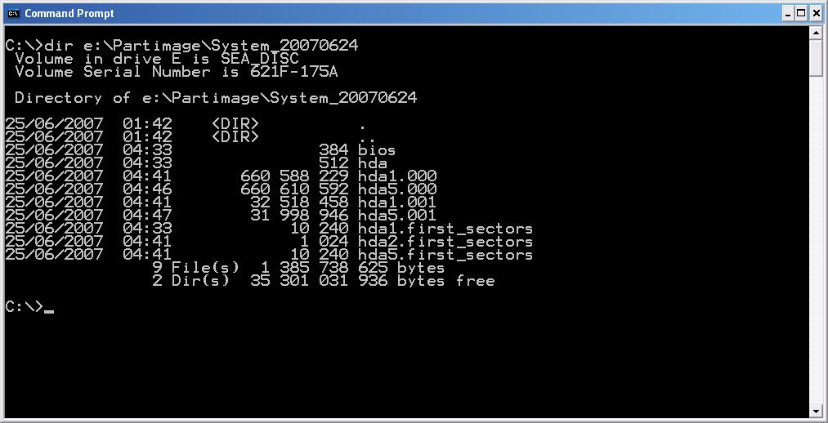 | On the directory we’ve stored the image into, you should get this kind of directory listing if you use the dir command in the Windows Command Prompt.
File Descriptions:
- bios stores a copy of your bios settings, and will be restored too. If you don’t want to restore or store your BIOS settings, delete this file.
- hda stores the first sector of the first hard disk drive. The file might be called sda if SCSI or S-ATA. The Master Boot Record (MBR) should be inside.
- hda1.000 and hda1.001 (or sda1.000 if SCSI/S-ATA) are the partimage image files of the first partition of the first hard disk drive. Delete these files if you don’t want this partition to be restored.
- hda1.first_sectors (or sda1.first_sectors if SCSI/S-ATA) stores the 20 first sectors of the first partition of the first hard disk drive. They will be restored before the partimaged image, to ensure any boot sector stored in a partition rather than in the MBR will be restored. The LVM structure of a partition (Linux-context only) is also stored here.

Storing an image on a Bootable ISO
Storing an image on a LAN computer is nice, but sometimes, you may want to burn this image on a bootable DVD. It can be useful to bring such a media to a remote site, and regenerate a computer. It can also be considered as a practical way to backup a whole system.
Directory names are given here as samples. Adapt the following according to your specific needs and configuration.
- We suppose you've recorder an image within the C:\PartImage\ directory. The image is called My_Image_2005-12-25.
- Download initrd.gz and save this file within the C:\PartImage\My_Image_2005-12-25\ directory.
- Download kernel and save this file within the C:\PartImage\My_Image_2005-12-25\ directory.
- Download isolinux.bin and save this file within the C:\PartImage\My_Image_2005-12-25\ directory.
- Create a text file, called isolinux.cfg, within the C:\PartImage\My_Image_2005-12-25\ directory, containing:
DEFAULT rescue
PROMPT 0
LABEL rescue
KERNEL kernel
APPEND vga=normal devfs=nomount pxe ramdisk_size=33000 load_ramdisk=1 init=/linuxrc prompt_ramdisk=0 initrd=initrd.gz root=/dev/ram0 rw noapic lba
- Download CDR Tools 2.0.1. Install the EXE (there’s an embedded MSI) on your computer.
- Open a DOS Prompt and go to your image directory:
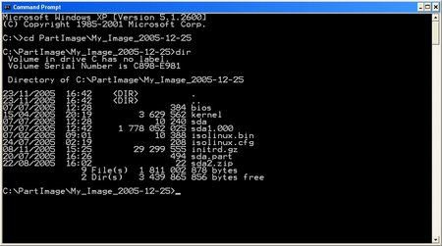
- Use mkisofs (from CDR Tools) to generate a bootable ISO:
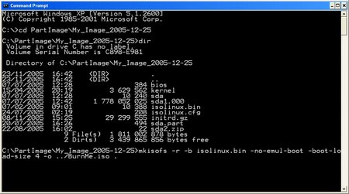
mkisofs -r -b isolinux.bin -boot-info-table -no-emul-boot -boot-load-size 4 -o ../BurnMe.iso .
/!\ Don’t forget the trailing dot. If you’re not familiar with DOS, remember that mkisofs.exe has to be stored somewhere in your PATH for this command to work. Why not store it in your C:\WINDOWS\SYSTEM32 directory ?
- The ISO generation should start...:
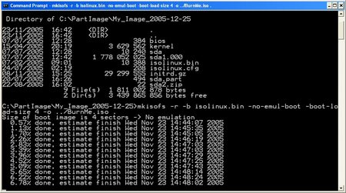
- And you should get a full working C:\PartImage\BurnMe.iso image.
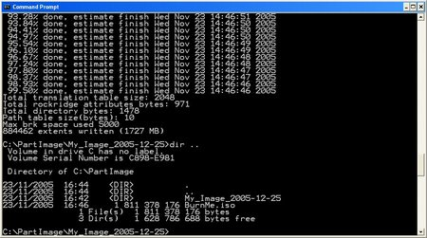
- Burn the ISO. That's all.
Note: You might use Ahead Nero or any third-party software to generate a bootable ISO. Your mileage might vary.

Annex
Notes :
- To suggest a new feature, please visit the Forum (PING section).
- TIP: if you've got to duplicate an image over several computers within a LAN, you'll have to regenerate Windows' SID. To do so, use newsid.exe from SysInternals.

Special features / FAQ :

- The PING.CONF file (read the whole paragraph before doing…)

If you’re bored with always having to re-type network and share settings…
  - You can add an answers file to the Linux image. It’s path is /etc/ping.conf and it already contains all available keys, in commented lines.
  - To modify it to suit your needs :

1. Boot PING on a machine that has at least 256 MB of RAM
2. Get a shell when proposed to, by typing 'x' and Enter
3. Login as root, no password
4. Connect to your network:
- If there's a DHCP server, type: dhcpcd eth0
- Else, type (adjust to your config):
- ifconfig eth0 192.168.0.26 netmask 255.255.255.0 up
- route add default gw 192.168.0.1
5. Mount a remote share (where your initrd.gz file can be found):
- mount.smbfs //192.168.0.1/d\$ /mnt/smbfs –o
username=domain\\username
(or just username=username if this is a local user)
6. Assuming both your initrd.gz and ping.conf files are located
in the root of the share, type:
- gzip -d /mnt/smbfs/initrd.gz
- mount -o loop /mnt/smbfs/initrd /mnt/loop
- mkdir /tmp/rootfs
- cd /tmp/rootfs
- tar xvfj /mnt/loop/rootfs.tar.bz2
- cp /mnt/smbfs/ping.conf /tmp/rootfs/etc/ping.conf
- tar cvf - * |bzip2 -9 - >/mnt/loop/rootfs.tar.bz2
- umount /mnt/loop
- gzip -9 /mnt/smbfs/initrd

Remember that Linux's shell is case-sensitive.

From PING 2.00 RC8, it’s possible to avoid having to modify the image to get the same result. Every key=value setting contained in the ping.conf file can be passed directly to the kernel at boot time. To do this, simply edit your isolinux.cfg file (if CD/DVD, pxelinux.cfg\DEFAULT if PXE), and modify the APPEND line accordingly. Be careful that DOS linefeeds will cause problems – so, either edit the sample file available from the download section of the PING web site, either use a unix-friendly editor like Ultra-Edit (tks Fubar Bundy for the tip).

For example, to have PING leave you to a shell after job completion, you’d add the string After_Completion=Shell to the APPEND line. Note that the syntax key=”value” is accepted, allowing space chars to be passed too.

If the ping.conf file has been customized, you still can pass keys/values to the kernel at boot time. They’ll be given priority over ping.conf’s data.

List of currently supported settings :

 | Key name | Possible Values / Examples | Description
Client network configuration | IP | Ex.: 192.168.0.1 | The IP address you want the client to be assigned. Pass no IP if you’ve got a DHCP and want to use it.
Client network configuration | Netmask | Ex.: 255.255.255.0 | The netmask corresponding to the IP.
Client network configuration | Gateway | Ex.: 192.168.0.1 | The gateway corresponding to the IP.
Client network configuration | DHCP_Timeout | Ex.: 15 | If you need to set a non-default timeout for DHCP, set it here in seconds.
Images location section | Server | Ex.: 192.168.0.1  Ex.: /dev/hda2,/dev/sda2 | The IP of the host where images made with PING are located.  The images can also be stored on a local partition; in such a case, mention it. If the images can be stored on different partitions, use commas to give several possible choices.
Images location section | Share | Ex.: MyShare | Name of the MS Share.
Images location section | User | Ex.: administrator | User to use (can be domain\user).
Images location section | Passwd | Ex.: secret | Password to send.
Images location section | Directory | Ex.: / | If you’ve made a directory in your share, give it here (ex.: \\192.168.0.1\MyShare\Partimage)
Misc | Repart | Y or N | If Repart is set to Y, and if you've got only one partition on your local hard disk drive and want to store an image of it locally, then this unique partition will be splitted for you. If set to N, PING will simply exit. And if commented, you'll be asked for what to do. May we suggest you'd better partition yourself for this kind of situation.
Misc | After_Completion | Shell or Reboot or Shutdown | What will PING do after the job is finished ? if Shell, you’ll be dropped to a Linux shell. Useful if you want to check the /tmp/x.log log.
Misc | Replace_BIOS | Y or N | Will we replace the BIOS if a "bios" file is found ? Note that you can simply delete this "bios" file before making your restorations to avoid having your bios params modified, but in some cases, you might want to have the bios settings recorded, and to restore them on a selection of target stations.
Misc | CIFS_Preferred | Y or N | To map a MS share, SAMBA can use either SMBFS either CIFS. For some reasons, it has been constated that CIFS can be much faster than SMBFS on some types of networks. And the contrary is true, too!
Misc | Zsplit_Preferred | Y or N | Set this to Y if you want zsplit, which is a dd-like utility, to be used instead of partimage. Most users should use partimage.
Misc | No_Shell | Y or N | Set this option to Y if you don’t want PING to propose the user to get a shell.  Note that if you have also set the After_Completion key to Shell, the user will finally be given a shell. If the After_Completion key is not set at all, then the user won’t be proposed to get a shell at the end of PING’s job.
Misc | Minimize_Before_Storing | Y or N | It can be interesting to reduce the size of the partition before storing it. Thus, it's possible to restore it later into a smaller partition. Note that even if we decide later to restore into a equally-big or bigger partition, PING will always try to maximize the size of the filesystem at the end.  You are strongly advised to have a full working backup of your system before choosing this option.
Misc | AUTO | Y or N | If you want NO QUESTION to be raised, no popup at all, set this value to Y. It's equivalent to creating an empty AUTO file on the root of a PING CD/DVD (which is now deprecated, yet still supported for backwards compatibility).
Misc | Cmd_1 |  | Cmd_1 is a shell command for PING to execute before the first blue welcome screen.
Misc | Cmd_2 |  | Cmd_2 is a shell command for PING to execute after the mounting of SMB shares.
Misc | Cmd_3 |  | Cmd_3 is a shell command for PING to execute at the end (before giving a shell or reboot or shutdown).
Misc | Compression_Type | Ex.: gzip | Set the compressor to be used. Else, will be asked. Can be set to 'gzip', 'bzip2' or 'no compression'.

- Can I restore an image to a bigger hard disk drive ?
  - Yes. Moreover, if the file system is NTFS, PING will always try to maximize its size, so you won’t end up with unallocated disk space.

- Can I restore an image to a smaller hard disk drive ?
  - Yes, roughly, starting with version 2.01.10 of PING.
  - How does it work ? at the recording of the image, you should choose to have the filesystem minimized as much as possible before being written. Then, it should be easy to restore it anywhere, since you can restore an image to a bigger partition.

- I’ve made a bootable DVD with my image and want no user interactivity at all.
  - Before creating your ISO with mkisofs, add an empty file to the directory containing your image, and call it “AUTO” (no extention). When seeing this file, PING will raise no question… unless the answer is really needed. Combine the AUTO file with a customized /etc/ping.conf.
  - You can also set the AUTO parameter, either in the /etc/ping.conf file, either by passing it to the kernel. See the params section for more details.
  - Of course, use at your own risk, as such a DVD will boot and scratch everything ☺

- What happens if I use a filesystem that is unknown to partimage ?
  - Then PING will record the partition with zsplit. It’s just like dd, yet faster. It will store your partition as bytes and not as files. Therefore, it will be much longer than what partimage would have done, and use far more space.
  - If you’ve got to industrialize the deployment of such partitions, consider blanking unused space (dd if=/dev/zero of=foobar ; rm foobar), and defragmenting. Then you should lose no space.

- Can I boot on a USB flash drive ?
  - Yes. Thanks to Blas and Fubar Bundy for the research & testing.
  - Mount your USB drive on Windows (say it’s F: ), preferably FAT32-formated.
  - Copy the following PING files to it => kernel, initrd.gz, isolinux.cfg .
  - On F:, rename isolinux.cfg to syslinux.cfg .
  - Download SYSLINUX from http://syslinux.zytor.com/download.php
  - Extract the file syslinux.exe from the file you’ve downloaded to your F: drive (it should be found here in the archive: x:\syslinux-3.51\win32\syslinux.exe)
  - Open a DOS prompt, and type: f:\syslinux.exe –ma f:

- My image is bigger than the capacity of a DVD. Can I store it on several DVDs ?
  - Yes. This is a pretty new feature.
  - Say you’ve got a directory structure like this :

Directory of E:\Partimage\T1_Bis

24/06/2007 06:38 384 bios
24/06/2007 06:38 512 hda
24/06/2007 06:55 660 588 216 hda1.000
24/06/2007 06:56 32 518 458 hda1.001
24/06/2007 06:38 10 240 hda1.first_sectors
24/06/2007 06:56 1 024 hda2.first_sectors
24/06/2007 06:56 10 240 hda5.first_sectors
24/06/2007 10:43 38 hda2_0.spl.zp
24/06/2007 09:30 660 616 876 hda5_0.spl.zp
24/06/2007 09:38 660 615 020 hda5_1.spl.zp
24/06/2007 09:45 660 613 560 hda5_2.spl.zp
24/06/2007 09:53 660 618 499 hda5_3.spl.zp
24/06/2007 10:05 310 638 295 hda5_4.spl.zp
13 File(s) 3 646 231 362 bytes

  - And say you’d like to store it in 6 CD-Roms.
  - Create an empty file in that directory, and call it “MULTI” (no extention).
  - Add PING files to make the future ISO bootable (initrd.gz, kernel, isolinux.cfg, and isolinux.bin).
  - You should have now :

Directory of E:\Partimage\T1_Bis

24/06/2007 06:38 384 bios
24/06/2007 06:38 512 hda
12/06/2007 10:37 4 164 232 kernel
25/06/2007 19:46 0 MULTI
24/06/2007 06:55 660 588 216 hda1.000
24/06/2007 06:56 438 213 hda5.000
24/06/2007 06:56 32 518 458 hda1.001
15/02/2007 11:44 10 932 isolinux.bin
22/06/2007 20:33 199 isolinux.cfg
24/06/2007 06:38 10 240 hda1.first_sectors
24/06/2007 06:56 1 024 hda2.first_sectors
24/06/2007 06:56 10 240 hda5.first_sectors
25/06/2007 14:10 22 766 432 initrd.gz
24/06/2007 10:43 38 hda2_0.spl.zp
24/06/2007 09:30 660 616 876 hda5_0.spl.zp
24/06/2007 09:38 660 615 020 hda5_1.spl.zp
24/06/2007 09:45 660 613 560 hda5_2.spl.zp
24/06/2007 09:53 660 618 499 hda5_3.spl.zp
24/06/2007 10:05 310 638 295 hda5_4.spl.zp
19 File(s) 3 673 611 370 bytes

  - First CD should contain the following files :

Directory of E:\Partimage\T1_Bis

24/06/2007 06:38 384 bios
24/06/2007 06:38 512 hda
12/06/2007 10:37 4 164 232 kernel
25/06/2007 19:46 0 MULTI
24/06/2007 06:55 660 588 216 hda1.000
24/06/2007 06:56 32 518 458 hda1.001
15/02/2007 11:44 10 932 isolinux.bin
22/06/2007 20:33 199 isolinux.cfg
24/06/2007 06:38 10 240 hda1.first_sectors
24/06/2007 06:56 1 024 hda2.first_sectors
25/06/2007 14:10 22 766 432 initrd.gz
24/06/2007 10:43 38 hda2_0.spl.zp
12 File(s) 720 060 667 bytes

  - Second CD should contain the following files :

Directory of E:\Partimage\T1_Bis

25/06/2007 19:46 0 MULTI
24/06/2007 06:56 10 240 hda5.first_sectors
24/06/2007 09:30 660 616 876 hda5_0.spl.zp
3 File(s) 660 627 116 bytes

(Note: you’ll call mkisofs this way (no boot): mkisofs -r -o ../Image_2.iso .)

  - Third CD should contain the following files :

Directory of E:\Partimage\T1_Bis

25/06/2007 19:46 0 MULTI
24/06/2007 09:38 660 615 020 hda5_1.spl.zp
2 File(s) 660 615 020 bytes

  - Forth CD should contain the following files :

Directory of E:\Partimage\T1_Bis

25/06/2007 19:46 0 MULTI
24/06/2007 09:45 660 613 560 hda5_2.spl.zp
2 File(s) 660 613 560 bytes

  - Fifth CD should contain the following files :

Directory of E:\Partimage\T1_Bis

25/06/2007 19:46 0 MULTI
24/06/2007 09:53 660 618 499 hda5_3.spl.zp
2 File(s) 660 618 499 bytes

  - Finally, sixth CD should contain the following files : (no more MULTI).

Directory of E:\Partimage\T1_Bis

24/06/2007 10:05 310 638 295 hda5_4.spl.zp
1 File(s) 310 638 295 bytes

- I’ve got some problems with the US keyboard…
  - To gain space, PING has been compiled with the US keyboard only. It’s qwerty, and we don’t plan to add other flavors.
  - It might help you to know that you can use ASCII codes. For instance, you can type a backslash (\) by holding the ALT key down and typying 92 at the same time. The ASCII code for the pipe (|) is 124.

- How to create a custom boot image on a floppy drive for PING ? If you happen to get an error like "PXE-E32: TFTP open timeout", this may mean you need to create a custom boot disk for your NIC. Here are the steps... (Thanks Curtis & Bobmetelsky for the tip)
  - Identify the NIC type and model. Windows users, right click on my computer, manage, device manager, network adapters.
  - Go to http://rom-O-Matic.Net/5.4.3/ and download the image yournic###.zdsk that matches your NIC.
  - Download the Windows GUI of rawwrite http://www.chrysocome.net/rawwrite to write the image file into a floppy. (UNIX users will just cat the zdsk file to /dev/fd0).
  - Create the boot floppy. Rawwite wants the name of the yournic###.zdsk and an A:\. From there, rawwrite will do all the work of creatiing the boot floppy. You do NOT need to create a system disk or anyting like that.
  - Boot the PC from the A:\ and and answer (N)etwork when prompted. The PC will boot and then look for your PXE server. From there, follow the standard PING documentation.

- The hard disk drive of my DELL series 2800 and 2850, which uses the Perc 4e/Di Controller, cannot be seen.
  - The Linux kernel uses MegaRAID drivers, and they are correct.
  - Yet, you should enter your MegaRAID BIOS Set Up Utility.
  - Enter the Adapter settings menu.
  - Under Other Adapter Options, select Emulation and set it to Mass Storage.
  - If the adapter is incorrectly set to "I2O" emulation, the system will attempt to load the i2o driver. This will fail, and prevent the proper driver from being loaded.

- How can I put the PING ISO into my harddisk and boot from it ?
  - PING can be used so to set up some kind of utility partition.
  - There are several ways to do it, and here's one of them. I've chosen to use lilo as a boot manager (either written in the MBR, either written into a file and called from the C:\boot.ini file), and to keep unchanged the files shipped with PING releases (that is, "kernel" and "initrd.gz"). That's the reason why there's still a ramdisk in the method described below, and even the keyword "pxe" in an append line. Really, other ways are possible.
  - Also, don't forget that you can ship your computer with an image stored on a second partition, and a bootable CDRom configured to automatically restore that image.

  - First method – using lilo within the MBR :
    - Boot a PING CDRom.
    - Get a shell when proposed to (type 'x').
    - In my system, there's only one IDE disk, which name is /dev/had (try sda for SATA/SCSI). So, here's the output of the "fdisk -l /dev/hda" command :

Disk /dev/hda: 8589 MB, 8589934592 bytes
255 heads, 63 sectors/track, 1044 cylinders
Units = cylinders of 16065 * 512 = 8225280 bytes
Device Boot Start End Blocks Id System
/dev/hda1 * 1 1044 8385898+ 7 HPFS/NTFS

    - We're going to store the restoration image and PING files in a second partition. We'll use EXT3 as the filesystem, to make the partition unreadable from Windows (well, difficult to read). Note that we could store the sole kernel file in a small EXT3 partition, and the cloned images on any filesystem. Let’s keep it simple – one EXT3 part.
    - In our example, a 2-GB-big partition is enough. First, let's resize our unique hda1 partition with the "ntfsresize -f -s 6000M /dev/hda1" command. Output :

ntfsresize v2.0.0 (libntfs 10:0:0)
Device name : /dev/hda1
NTFS volume version: 3.1
Cluster size : 4096 bytes
Current volume size: 8587153920 bytes (8588 MB)
Current device size: 8587160064 bytes (8588 MB)
New volume size : 5999993344 bytes (6000 MB)
Checking filesystem consistency ...
100.00 percent completed
Accounting clusters ...
Space in use : 1577 MB (18.4%)
Collecting resizing constraints ...
Needed relocations : 0 (0 MB)
WARNING: Every sanity check passed and only the dangerous operations left.
Make sure that important data has been backed up! Power outage or computer
crash may result major data loss!
Are you sure you want to proceed (y/[n])?

    - Now, using fdisk, we must resize hda1 to 6000M, and create a new partition. Command: “fdisk /dev/hda”.
    - In our case, the fdisk commands are “p d n p 1 1 +6000M t 7 a 1 n p 2 enter enter w”, resulting in this “fdisk –l /dev/hda” output :

Disk /dev/hda: 8589 MB, 8589934592 bytes
255 heads, 63 sectors/track, 1044 cylinders
Units = cylinders of 16065 * 512 = 8225280 bytes

Device Boot Start End Blocks Id System
/dev/hda1 * 1 730 5863693+ 7 HPFS/NTFS
/dev/hda2 731 1044 2522205 83 Linux

    - Finally, let's format hda2: “mkfs.ext3 /dev/hda2”.
    - Now, let's mount the two parts :
      - mount -t ntfs-3g /dev/hda1 /mnt/dos
      - mount /dev/hda2 /mnt/linux
    - df should output something like :

Filesystem 1K-blocks Used Available Use% Mounted on
/dev/hdc 19582 19582 0 100% /mnt/cdrom
/dev/hda1 5859368 1539268 4320100 27% /mnt/dos
/dev/hda2 2482556 69304 2287144 3% /mnt/linux

    - We've got to store PING's files in our new linux partition :
      - cp /mnt/cdrom/initrd.gz /mnt/linux
      - cp /mnt/cdrom/kernel /mnt/linux

    - Let's now write a lilo.conf file for /sbin/lilo to rewrite our MBR. It must be able to boot Windows on our hda1 partition, and Linux on the second one, with a (customizable but not customized here) text menu. Command: "vi /etc/lilo.conf" (i to insert text, :wq to save and exit). My lilo.conf file :

boot = /dev/hda
map = /mnt/dos/map
prompt
timeout = 150
vga = normal
lba32
delay = 30
read-only
large-memory
root = current

other = /dev/hda1
label = windows

image = /mnt/linux/kernel append="pxe init=/linuxrc root=/dev/ram0 rw noapic nolapic lba devfs=nomount ramdisk_size=33000 load_ramdisk=1 prompt_ramdisk=0"
label = restoration
initrd = /mnt/linux/initrd.gz

    - Rewrite the MBR. Command: "lilo". It should output :

Added windows *
Added restoration

    - Optionally, you can create directories on your linux partition, to replicate the contents of the Partimage.zip file. But PING will always propose you to create an image, and you can store it on the root of the partition.

    - You should now be able to boot your system and access PING if needed. You'll do so at least once, so to write on the linux partition the image of your windows system. Afterwards, if you don't want any more users to be able to boot this linux partition and do whatever they want with it, you still can customize the append="" section of your /etc/lilo.conf file (and rewrite the mbr). The optional parameters are described in the howto's annex.

  - Second method – writing lilo to the linux partition, and having Windows’s boot sector boot optionally the linux restoration partition through the edition of the C:\boot.ini file :
    - The procedure is almost similar to the first method.
    - The /etc/lilo.conf file will be slightly different :
      - First line will be: boot = /dev/hda2
      - You’ll have to add a ignore-table entry.
      - We’ll remove the Windows entry, and set the delay to 0 second.
      - So, your /etc/lilo.conf file should look like this :

boot = /dev/hda2
map = /mnt/dos/map
prompt
timeout = 150
vga = normal
lba32
delay = 0
read-only
large-memory
root = current
ignore-table

image = /mnt/linux/kernel append="pxe init=/linuxrc root=/dev/ram0 rw noapic nolapic lba devfs=nomount ramdisk_size=33000 load_ramdisk=1 prompt_ramdisk=0"
label = restoration
initrd = /mnt/linux/initrd.gz

    - When running the “lilo” command, you might get warnings, that can be safely ignored.
    - After running “lilo”, we’ll have to extract the boot sector that has been written into the /dev/hda2 partition, and store it as a file in our Windows partition. Command: “dd if=/dev/hda2 of=/mnt/dos/bootsect.lnx bs=512 count=1”.
    - Finally, on our C:\boot.ini, we’ll append a line to the [operating systems] paragraph so to call our new C:\bootsect.lnx sector : “echo "C:\\BOOTSECT.LNX="Restoration" >> /mnt/dos/boot.ini”.

- How can I use PING with VMWare’s SCSI controllers ?
  - You’ll have to check the LSI box (tks Tahussle).

- How can I add components to the PING image without modifying the initrd.gz file ?
  - From version 2.01.11, you can add or modify files after the PING OS has booted. To do so, simply add to the root of your CD/DVD files called addon-xxxx.tar.gz. All addon-*.tar.gz found at this place will be untarred to the root of the OS.
  - For example, we have used this feature to provide the users with a PING ISO which contains the CLAM anti-virus. The initrd.gz file contained in the PING-2.01-WithAddons.iso image is exactly same as the one contained in the PING-2.01.iso image, but the file addon-clamav.tar.gz has been added to the WithAddons ISO.
  - If you plan to use this feature in a PXE environment, then the addon-*.tar.gz files should be stored in the directory that contains your image directories. Obviously, they will only be untarred after the network shares are mounted.
  - TIP: you might want to combine this addon feature with parameters Cmd_1, Cmd_2 and Cmd_3.

- I wanted to save an image to my Maxtor USB-drive, but ping can only see the ordinary IDE and the SATA disks. I can see the USB drive in the bios.
  - If your BIOS settings has an option for plug and play (PNP) operating system, set it to disable or off (tks Ken).

